OPTICAL CHARACTER RECOGNITION
Akshit Tandon, Sahil Srivastava, Chirag Arora, Abhishek Sharma
Department of Information Technology, Northern India Engineering College, Delhi, India

Abstract It has been 50 years since the idea popped up that calculating systems can be made on the replica of the biological neural networks. Still, the development of this science branch made the improvement of these systems possible only in the last 25–30 years. Nowadays, Neural Computing is a very extensive, separate science. Its solid theory basis made it possible to use them to solve many kind of problems in artificial computing, thus improving the experience of the science. Neural networks are commonly used to solve sample-recognition problems. One of these is character recognition. The solution of this problem is one of the easier implementations of neural networks. With the help of ASP.net and C# language, we tried to recognize printed and handwritten characters by projecting them on different sized grids (5×7, 7×11, 9×13). The results showed that the precision of the character recognition depends on the resolution of the character projection. Also, we realized, that not every writing style can be recognized using the same network with the same precision. This shows that the variety of human handwriting habits can't be fully covered with one neural network.

Index Terms—Artificial Computing, Neural Computing, Neural Networks, Character Recognition, Character Projection

INTRODUCTION
The purpose of this project is to identify handwritten characters using Neural Network Algorithms.
One of the primary means by which computers are endowed with human like abilities is through the use of Neural Networks. Neural Networks are particularly useful for solving problems that cannot be expressed as a series of steps such as recognizing pattern, classifying them into groups, series prediction and data mining [2].
The project will have the following three capabilities:

OPTICAL CHARACTER RECOGNITION

Handwritten Character
Recognition
QR Code
Generation
Image
Processing
Character

Figure 1: OCR

Handwritten character recognition
Handwriting recognition is the ability of a computer to receive and interpret intelligible handwritten input from sources such as paper documents, photographs, touch-screens and other devices. The image of the written text may be sensed "off line" from a piece of paper by optical scanning (optical character recognition) or intelligent word recognition. Alternatively, the movements of the pen tip may be sensed "on line", for example by a pen-based computer screen surface, a generally easier task as there are more clues available. Handwriting recognition principally entails optical character recognition. However, a complete handwriting recognition system also handles formatting, performs correct segmentation into characters and finds the most plausible words.

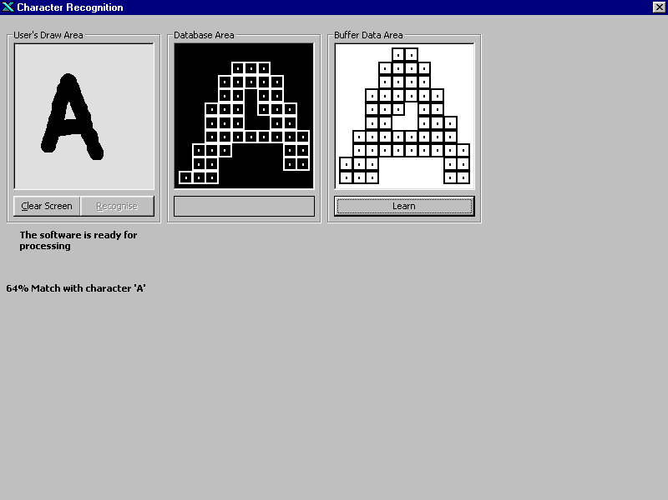
Figure 2: Identification
Figure 2 description:

- The first picture is the user’s draw area which accepts the inputs from the users using the VB’s graphic command: Pset (x,y) which sets the pixel at the specified point (x,y).
- The second picture box is the database area which shows the patterns read from the database file which in this case is ‘DATA.rec’. It again uses the function Pset (x,y)
- The third picture box is the bit-wise representation of the user’s draw area.

Image processing
Image processing is the use of computer algorithms to perform image processing on digital images. As a subcategory or field of digital signal processing, digital image processing has many advantages over analog image processing. It allows a much wider range of algorithms to be applied to the input data and can avoid problems such as the build-up of noise and signal distortion during processing.
Since images are defined over two dimensions (perhaps more) digital image processing may be modelled in the form of multidimensional systems. Optical character recognition (OCR) is the translation of optically scanned bitmaps of printed or written text characters into character codes, such as ASCII. This is an efficient way to turn hard-copy materials into data files that can be edited and otherwise manipulated on a computer.

QR Code generation
QR code is the trademark for a type of matrix barcode (or two-dimensional barcode) first designed for the automotive industry in Japan. A barcode is a machine-readable optical label that contains information about the item to which it is attached. A QR code uses four standardized encoding modes (numeric, alphanumeric, byte/binary, and kanji) to efficiently store data; extensions may also be used. The QR code system became popular outside the automotive industry due to its fast readability and greater storage capacity compared to standard UPC barcodes. Applications include product tracking, item identification, time tracking, document management, and general marketing. A QR code consists of black squares arranged in a square grid on a white background, which can be read by an imaging device such as a camera, and processed using Reed–Solomon error correction until the image can be appropriately interpreted. The required data is then extracted from patterns that are present in both horizontal and vertical components of the image.[4]

Methods
The proposed project comprises of four phases:

- Pre-Processing
- Segmentation
- Feature Extraction
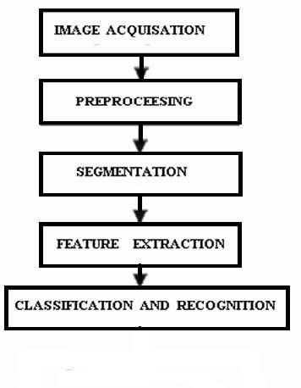

Figure 3: Phases

- Pre-Processing
The handwritten character data samples were acquired from various students and faculty members both male and female of different age groups. Their handwriting was sampled on A4 size paper. They were scanned using flat-bed scanner at a resolution of 100dpi and stored as 8-bit grey scale images. Some of the common operations performed prior to recognition are smoothing, thresholding and skeletonization.

Image Smoothing

The task of smoothing is to remove unnecessary noise present in the image. Spatial filters could be used. To (IJCSIS) International Journal of Computer Science and Information Security, Vol. 4, No. 1 & 2, 2009 reduce the effect of noise, the image is smoothed using a Gaussian filter [1].

Skeletonization

We have initialized the mouse in graphics mode so that a character can be directly written on screen. The skeletonization process has been used to binary pixel image and the extra pixels which do not belong to the backbone of the character, were deleted and the broad strokes were reduced to thin lines. Skeletonization process is illustrated in Figure2. A character before and after skeletonization is shown in Figure 2a and 2b respectively [1].

Normalization

After skeletonization process, we used a normalization process, which normalized the character into 30x30-pixel character and it was shifted to the left and upper corner of pixel window. The final skeletonized and normalized character is shown in Figure 2c, which was used as an input of the neural network. The Skeletonization and Normalization process were used for each character [1].

- Image Acquisition

In this phase the input image taken through camera or some scanner. The image should have a specific format such as JPEG; BMT etc. The input captured may be in gray, color or binary from scanner or digital camera.
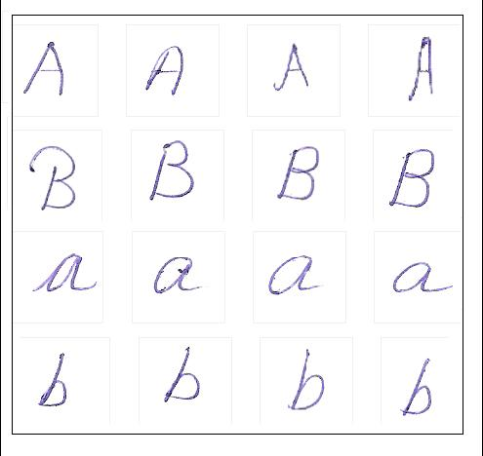

Figure 4: Sample Dataset

- Segmentation

In Character Recognition techniques, the Segmentation is the most important process. Segmentation is done to make the separation between the individual characters of an image. Segmentation of unconstrained handwritten word into different zones (upper middle and lower) and characters is more difficult than that of printed documents. This is mainly because of variability in inter-character distance, skew, slant, size and curved like handwriting. Sometimes components of two consecutive characters may be touched or overlapped and this situation complicates the segmentation task greatly. In Indian languages such touching or overlapping occurs frequently because of modified characters of upper-zone and lower-zone. Segmentation is an important stage, because the extent one can reach in separation of words, lines or characters directly affects the recognition rate of the script. [7]

There are two types of segmentation: External and Internal.

- Feature Extraction

Feature extraction is the process to retrieve the most important data from the raw data. The most important data means that’s on the basis of that’s the characters can be represented accurately. The major goal of feature extraction is to extract a set of features, which maximizes the recognition rate with the least amount of elements. In feature extraction stage each character is represented as a feature vector, which becomes its identity. Due to the nature of handwriting with its high degree of variability and imprecision obtaining these features, is a difficult task. Feature extraction methods are based on 3 types of features-Statistical, Structural, Global transformations and moments [6]. Structural and statistical features appear to be complementary in that they highlight different properties of the characters. The widely used feature extraction methods are Template matching, Deformable templates, Unitary Image transforms, Graph description, Projection Histograms etc.

OCR CLASSIFICATION
Online Recognition: Online handwriting recognition involves the automatic conversion of text as it is written on a special digitizer or PDA, where a sensor picks up the pen-tip movements as well as pen-up/pen-down switching. This kind of data is known as digital ink and can be regarded as a digital representation of handwriting. The obtained signal is converted into letter codes which are usable within computer and text-processing applications
.
Offline Recognition: Offline recognition operates on pictures generated by an optical scanner. The data is two-dimensional and space-ordered which means that overlapping characters cannot be separated easily. Offline handwriting recognition involves the automatic conversion of text in an image into letter codes which are usable within computer and text-processing applications. The data obtained by this form is regarded as a static representation of handwriting. Offline handwriting recognition is comparatively difficult, as different people have different handwriting styles.[9]

OCR ALGORITHM

Neural Network Algorithm

An Artificial Neural Network (ANN) is an information processing paradigm that is inspired by the way biological nervous systems, such as the brain, process information. It is composed of a large number of highly interconnected processing elements (neurons) working in unison to solve specific problems. A neural network is a powerful data modelling tool that is able to capture and represent complex input/output relationships. The motivation for the development of neural network technology stemmed from the desire to develop an artificial system that could perform "intelligent" tasks similar to those performed by the human brain. Neural Network consists three layers - input layer, hidden layer (optional) and output layer.[8]

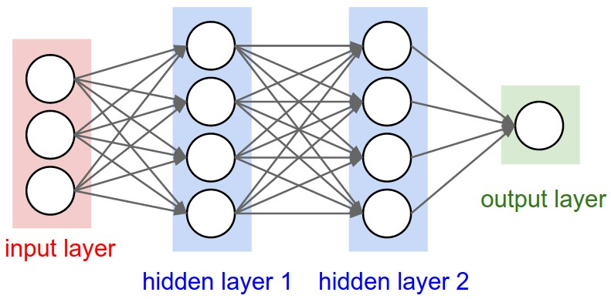
Figure 5: Layers
The input layer is the conduit through which the external environment presents a pattern to the neural network. Input layer take input from the external world and encode it into a convenient form. Every input neuron should represent some independent variable that has an influence over the output of the neural.
Hidden layer can’t see or act upon the outside world directly. These interneurons communicate only with other neurons. Deciding the number of neurons in the hidden layers is a very important part of deciding your overall neural network architecture. Both the number of hidden layers and the number of neurons in each of these hidden layers must be carefully considered.[8]
The output layer of the neural network is what actually presents a pattern to the external environment. The number of output neurons should be directly related to the type of work that the neural network is to perform.

Statistical Algorithm

The purpose of the statistical algorithms is to determine to which category the given pattern belongs. By making observations and measurement processes, a set of numbers is prepared, which is used to prepare a measurement vector. Statistical algorithm uses the statistical decision functions and a set of optimality criteria which maximizes the probability of the observed pattern given the model of a certain class. Statistical algorithms are mostly based on three major assumptions: [5]

- Distribution of the feature set.
- There are sufficient statistics available for each class.
- Collection of images to extract a set of features which represents each distinct class of patterns.

Conclusion

It is believed that this detailed discussion will be beneficial insight into various concepts involved, and boost further advances in the area. The accurate recognition is directly depending on the nature of the material to be read and by its quality. Current research is not directly concern to the characters, but also words and phrases, and even the complete documents. From various studies we have seen that selection of relevant feature extraction and classification technique plays an important role in performance of character recognition rate. This review establishes a complete system that converts scanned images of handwritten characters to text documents. This material serves as a guide and update for readers working in the Character Recognition area.

Future Work

A lot of Research is still needed for exploiting new features to improve the current performance. We can use some features specific to the mostly confusing characters, to increase the recognition rate. To recognize strings in the form of words or sentences segmentation phase play a major role for segmentation at character level and modifier level. So, there is still a need to do the research in the area character recognition.

References
- https://arxiv.org/ftp/arxiv/papers/0908/0908.4386.pdf
- https://www.slideshare.net/chiranjeeviadi/hand-written-character-recognition-using-neural-networks
[3] http://ieeexplore.ieee.org/document/7054772/
[4] https://studio.uipath.com/docs/output-or-screen-scraping-methods
[5] https://www.nr.no/~eikvil/OCR.pdf
[6] http://www.explainthatstuff.com/how-ocr-works.html
[7] http://lib.stat.cmu.edu/apstat/
[8] https://www.analyticsvidhya.com/blog/2014/10/ann-work-simplified
[9] https://in.mathworks.com/products/image.html

